Scissor Development
momaot.com
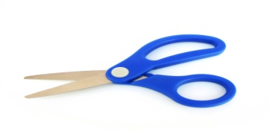
Scissor Components:
*postural stability*hand strength*dexterity*hand eye coordination*bilateral integration*sensory integration
Developmental Progression of scissor work:
2 YEARS
-Tearing Paper
-Snipping Paper (no lines)
3 YEARS
-Snipping in a forward motion (straight lines)
4 YEARS
-Cut forward on all lines
5 YEARS
-Cut all lines and shapes
6 YEARS
-Cut complex pictures
Tips For Learning Scissors
*Open/close hand motion activities
*Tearing paper
*Teach proper scissor hold
-thumb up
-visual cue (smiley face on thumb)
-keep elbow in
-helper hand
-“push” forward
-try standing
*Hand over hand assistance
*Snip dough/stiff items to start (straws/cardstock)

ENCOURAGE SCISSOR WORK AT HOME!
