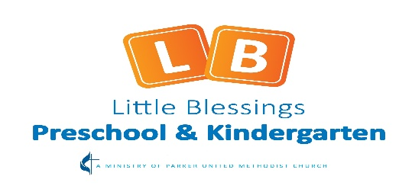

Navigating Kindergarten registration for your child!
There are so many programs and options for kindergarten—how will you know which kindergarten is right for your child? Douglas County is fortunate enough to have options for parents to choose the right fit for their child. The number of options however can feel confusing. It is a matter of finding a program that aligns with your goals for your child and what you value in an educational experience. The below information will help you navigate registration for Kindergarten but also offer some questions to explore as you visit different programs.
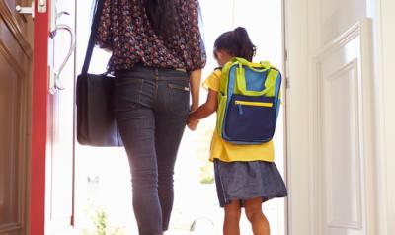
Douglas County Public Schools Kindergarten Options:
- Neighborhood Public- All new student registrations are done at your School of Residence or neighborhood school. Not sure which neighborhood school your children should attend? You can find the school boundary information on the Boundary Maps tab on the Douglas County Public School Website https://www.dcsdk12.org. If you can't find the neighborhood school information on the Boundary Maps tab, please contact 303-387-9500.
- Charter Public - A charter school is a tuition-free public school operated by an independent board of directors that may be composed of parents, teachers and community members. A charter school is a school of choice within the school district, operating under a contract or "charter" between the board of the charter school community and the DCSD Board of Education. Visit DCSD website for a list of Charter School options https://www.dcsdk12.org.
- Private - Independent programs with tuition fees such as Little Blessings or other Christian based programs operated by a board. Little Blessings begins pre-registration for the upcoming school year on December 14th. Details about pricing and the Kindergarten schedule at Little Blessings are listed below.

Little Blessings Kindergarten:
- Little Blessings has one Kindergarten classroom taught by state certified teacher Ms. Murphy
- Class ratio is 12 students
- Monday – Thursday 9:00-2:00 & Friday 9:00-11:30
- Tuition $535 a month with an enrollment fee of $340
- Little Blessings meets all Douglas County and state standards for entering 1st grade
- “The day in the life of a Little Blessings Kindergarten student video” will be shared with all Kindie Prep classrooms the week of December 14th.
Required documents for Registration for DCSD Neighborhood or Charter Public:

- Birth Certificate (State certified preferred)
- Immunization Records Colorado Law
- Proof of Residence (Warranty Deed, Deed of Trust, Property Tax Notice, Lease Agreement, County Assessor Page or Notarized Proof of Residency letter from the person you are living with (if your name doesn't appear on the proof of residency) along with a copy of their proof of residency.

DCSD Kindergarten Open Enrollment:
First Round Open Enrollment will open on November 2nd at 8:00am and closes on December 1st at 4:00pm. Schools will extend offers of open enrollment based on space availability by December 8th. Parents can see offers in the EngagED Parent Portal on December 11th at 8:00 am and have until December 18th at 4:00 pm, to log back in and accept any open enrollment offers. In the event you did not receive any offers during First Round, you will remain on a waitlist for Second Round of Open Enrollment, which opens on January 22nd at 8:00 am.
**Second Round Open Enrollment runs from January 22, 2021 through August 2, 2021 at 4:00pm. If you were put on the wait list during the first round, you will still be on that list for the second round. Schools will ONLY reach out to you when and if a spot becomes available**
Open Enrollment is now Open
Questions to ask when you visit Kindergarten programs:

- Does this school meet my basic needs?
- What is the student - teacher ratio?
- How are behavior problems handled?
- What distinguishes your school from others?
- How much homework will my child have?
- How do you support different learning styles and needs?
- How are teachers supported and held to a high standard?
- What are the schools expectations for the Kindergarten students?

Readiness skills for Kindergarten:
- Writing name
- Following 2 step directions
- Exposure to early concepts such as letter recognition, number recognition, sounds of letters and counting
- Passion for books (read to your children often)
- Independence in self-help skills (packing backpack, putting on coat, bathroom needs, etc.)

Not sure your child is ready for Kindergarten:

Children grow and develop at different rates. Does your child have a late summer birthday or just miss the district cutoff date (October 1st)? Do you want your child to attend an additional year of Kindie Prep? Little Blessings has 3 day and 5 day, Young 5’ Kindie Prep options for the 2021-2022 school year.

